**The woman at the well**

**Reading: from John 4:1-30**

In Samaria Jesus came to the town called Sychar. Jacob’s well was there. Jesus was tired from his long trip, so he sat down beside the well. It was about noon. A Samaritan woman came to the well to get some water, and Jesus said to her, “Please give me a drink.”

The woman answered, “I am surprised that you ask me for a drink! You are a Jew and I am a Samaritan woman.” (Jews have nothing to do with Samaritans.)

Jesus answered, “You don’t know what God can give you. And you don’t know who I am, the one who asked you for a drink. If you knew, you would have asked me, and I would have given you living water.”

The woman said, “Sir, where will you get that living water? The well is very deep and you have nothing to get water with.”

Jesus answered, “Everyone who drinks this water will be thirsty again. But anyone who drinks the water I give will never be thirsty again. The water I give will be like a spring flowing inside them. It will bring them eternal life.”

The woman said, “Sir, give me this water. Then I will never be thirsty again and won’t have to come back here to get more water.”

Then the woman left her water jar and went back to town. She told the people there, “A man told me everything I have ever done. Come and see him. Maybe he is the Christ.”

**Thought about the reading**

When Jesus was alive, men did not think much of women. They did not talk to women. Jesus was a Jew. Jews also did not talk to people who lived in Samaria. So, when Jesus sat at the well, he should not have spoken to the woman who was a Samaritan.

But Jesus never ignores anyone. He welcomes everyone, no matter who they are, or what other people think of them.

Water is important because we cannot live without it. Jesus told the woman he would give her ‘living water.’ He meant that if she decided to follow him, she would live forever in heaven with him. He would give her eternal life.

Jesus offers this living water to everyone, no matter who we are. He welcomes us all.

**Prayer**

Dear Jesus, thank you that you offer ‘living water’ to everyone. Like the woman, I want to say, ‘Please give me this water.’

Amen

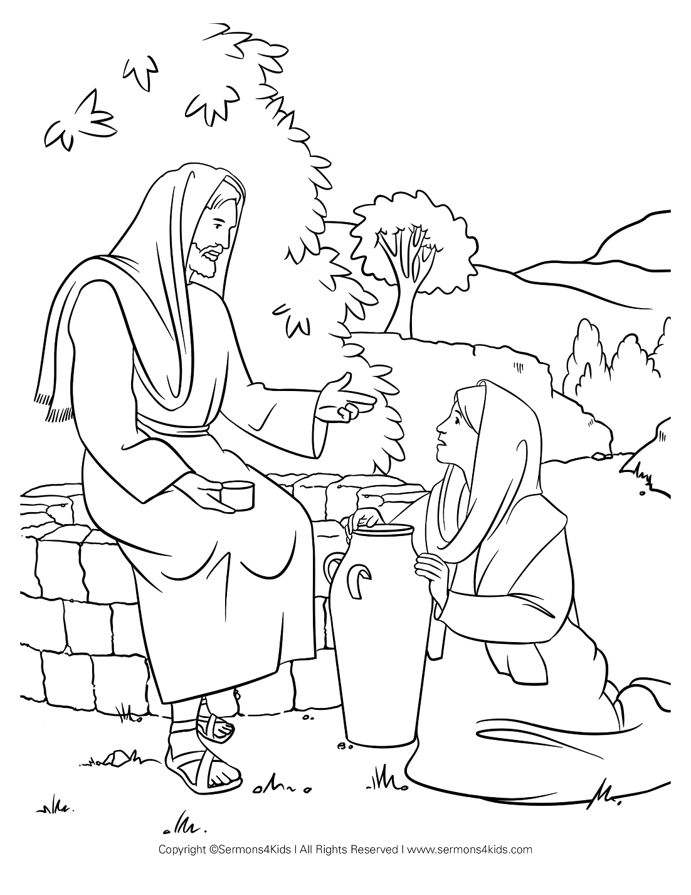

**Cambridge Causeway**

Spring 2025

Bible Study notes

**People changed by Jesus**

**4. The woman at the well.**

By Chrissy Cole